**System Manual**

Cleft Lip Aesthetics Tool

This system manual has been created for the purpose of allowing for future development to take place on this project without much confusion. Outlined below are the details required for setting up and running the project.

**Initial requirements**

The computer being used for building the app must meet the following minimum system requirements:

* Microsoft® Windows® 7/8/10 (32- or 64-bit)
* 1.6 GHz or faster processor
* 3 GB RAM minimum, 8 GB RAM recommended
* 9 GB of available hard disk space (Includes Android and Windows SDK)
* 1280 x 768 minimum screen resolution

1. **Downloading dependencies**

Cordova runs on Node.js which needs to be downloaded and installed first from: <https://nodejs.org/en/>

Once Node.js has been installed, Cordova can be installed from the command prompt by typing npm install -g cordova.

Full details can be seen on: https://cordova.apache.org/#getstarted

Additional platform dependencies need to be installed, in this case Android and Windows.

To set up the SDK environment for Android, the Java Development Kit 7 or later must first be installed from: <http://www.oracle.com/technetwork/java/javase/downloads/index.html>

The JAVA_HOME environment variable needs to be set depending on the Java installation path.

Android Studio must next be downloaded and installed, which comes with the Android SDK, for full Cordova functionality from: <https://developer.android.com/studio/install.html?pkg=studio>

The highest SDK version should be installed. The latest build-tools should also be installed.

The Android_HOME environment variable needs to be set depending on the Android SDK installation path.

Full details can be seen on: https://cordova.apache.org/docs/en/latest/guide/platforms/android/index.html

The Windows SDK is available for download with Visual Studio 2015 or newer from: <https://www.visualstudio.com/downloads/>

The feature to be selected for installation with Visual Studio is Universal Windows App Development Tools.

Full details can be seen on: https://cordova.apache.org/docs/en/latest/guide/platforms/win8/index.html

1. **Retrieving source code**

All of the source code for the project is available in a private repository at: <https://github.com/Farbas1/Cleft-Lip-Individual-Project>

A GitHub username and password have been supplied elsewhere to provide access to this repository.

The code for the server-side can be found in the Server side folder. The Cordova app code can be found in the Aesthetics Tool App folder.

1. **Setting up project**

The main source code for the app is stored in the www folder. The files can be edited in any text editor such as Notepad++. Alternatively, the project can be opened up in the Visual Studio IDE by going to the platforms and then windows folder and clicking on CordovaApp.Windows10.jsproj. This will automatically load all relevant files, available for editing, debugging and running.

1. **Building & running app**

To build and run the app, open a command prompt in the Aesthetics Tool App directory. For Android, type cordova run android to run the app on a physical device. Alternatively, cordova emulate android can be used to run the app on an emulator. To build the app and not run the app, type cordova build android.

For Windows, type cordova run windows --arch=x64 into the command prompt to build and run the app. The –-arch value must be stated and can be either x64, x32 or ARM. Alternatively, the app be built and not run with cordova build windows --arch=x64.

If the project is being used in the Visual Studio IDE, simply select the CPU type at the top of the screen and then select to run the app on either Local Machine, Simulator or Device. This is demonstrated in the image below.

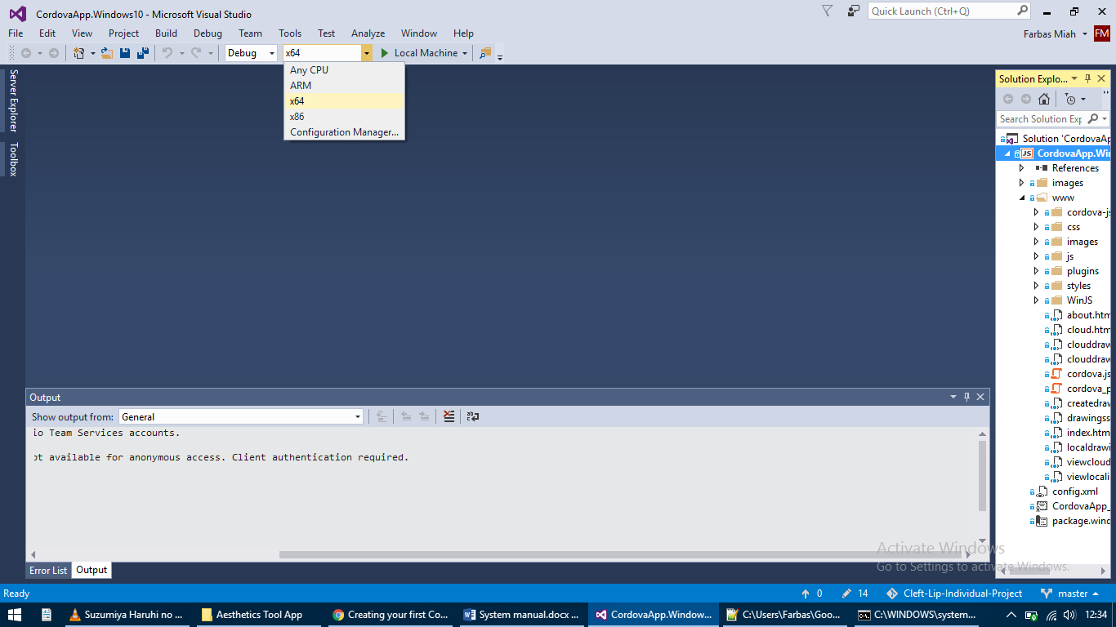

1. **Accessing server-side**

The server has been set up on a free host and is accessible from: <https://www.000webhost.com/>

Login details have been provided elsewhere to provide access to the server.

Once logged in, the PHP code can be accessed by clicking on the File manager tab at the top of the page.

The database is accessible by clicking on the Manage database tab at the top of the page and then opening the database with PhpMyAdmin.

1. **Adding new patients**

Once the database has been opened with PhpMyAdmin, two tables are available. The drawings table simply contains data related to the drawings uploaded by users. The images table is where patients are located.

To add a new patient, click on the images table and then the Insert tab at the top of the page. There are four columns of data to input, the first of which is the ID and can be ignored as it increments automatically. The following three columns to input data for are name, date and image. The name and date can be inserted in any format, preferably with a standard format. The image column accepts only base64 data which is an image in text format.

Once the data has been filled in, click Go to complete adding a patient into the database. New patients will be visible to users immediately on all platforms.